# Assignment 1

* **Install Power BI Desktop and share the final screenshot of the report view page which appears when power desktop starts.**

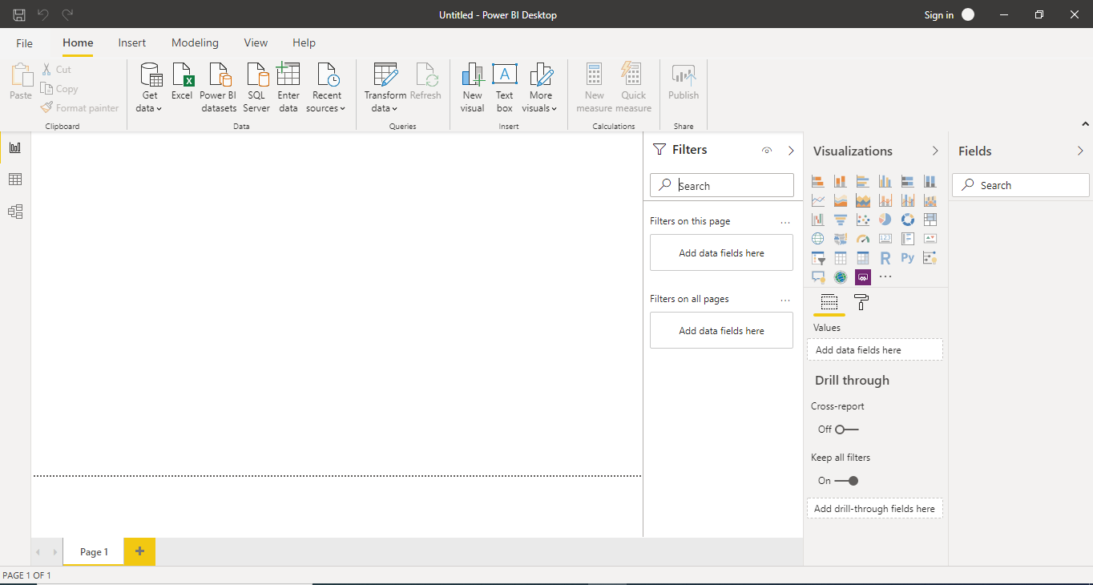

**Data View:**

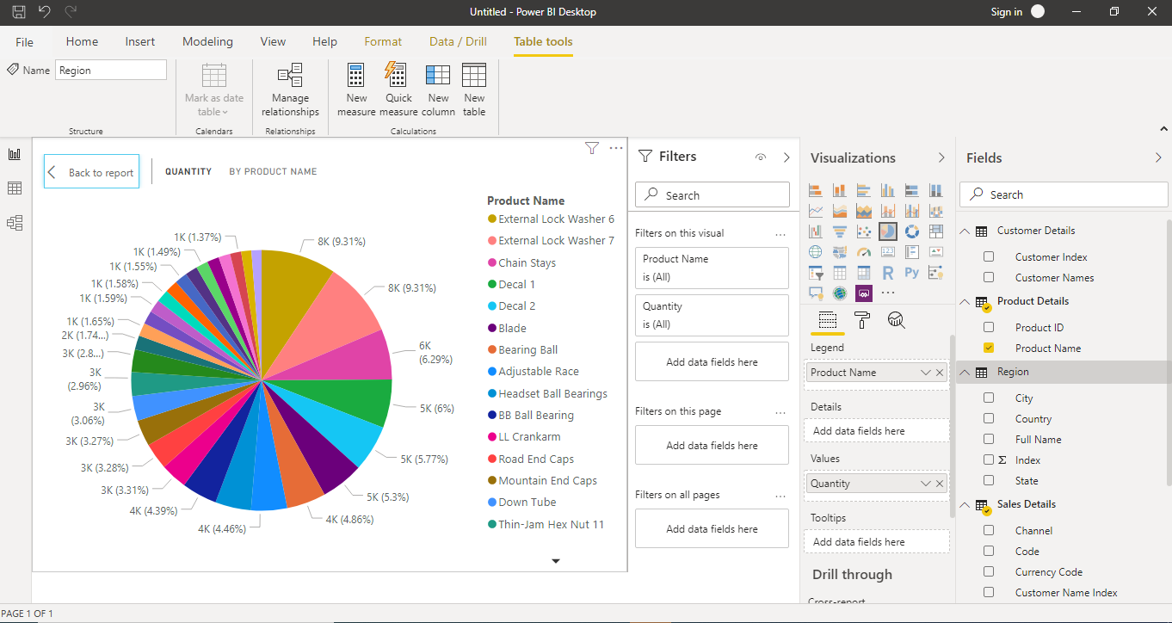

**Model View:**

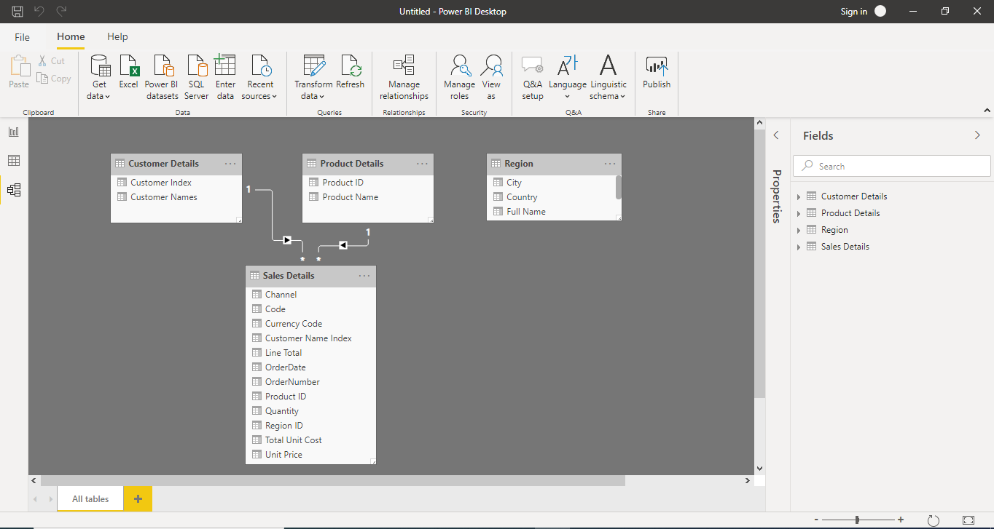

**Power Query Editor :**

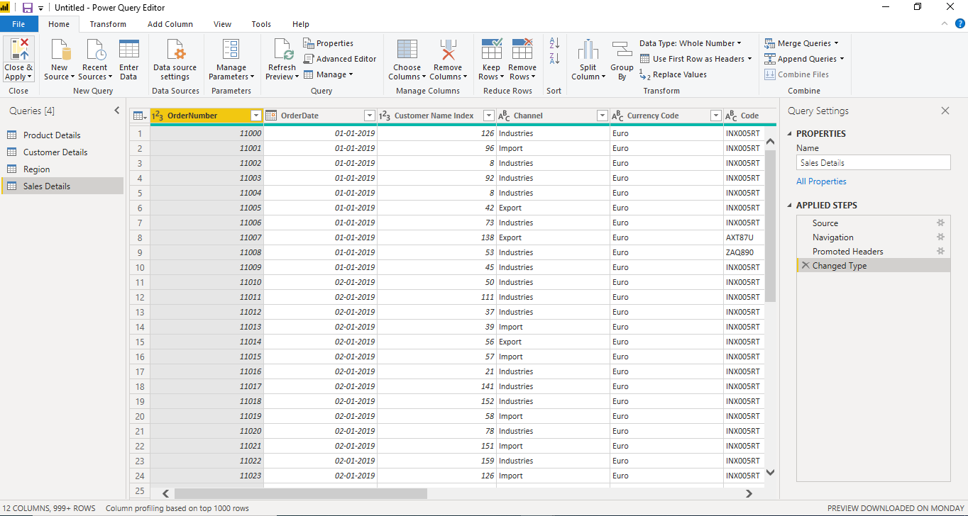

**Advance Editor :**

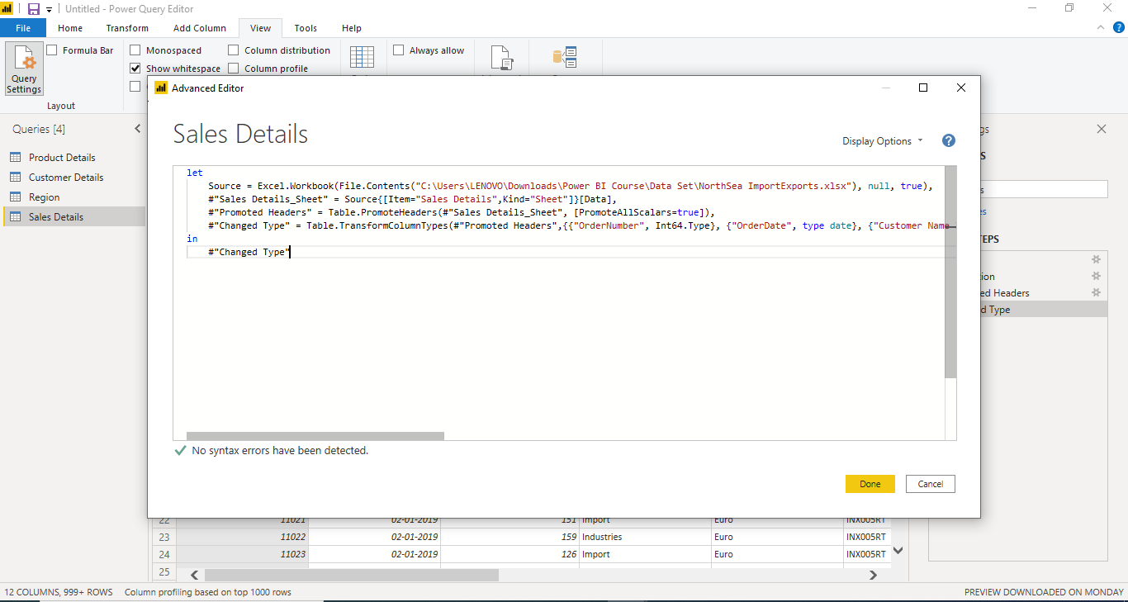

**Power BI Desktop:**

Power BI Desktop is the free version of Power BI that you can install on your local computer as a program, and acts as a companion desktop application to the full version of Power BI. If you need to consolidate your data sources, create your own reports and conduct your own analysis or test it’s capabilities, it’s the perfect version to start with for all skill levels - whether you’re non-IT and want to make your reports more interactive, or analysts seeking richer detail, it's one of the best business analytics tools to use.

Despite its free nature, you may be surprised at what Microsoft has included with Power BI Desktop:

* You can connect and import data from over 70 cloud-based and on-premises sources
* The same rich visualisations and filters from Power BI Pro
* Auto-detect that finds and creates data relationships between tables and formats
* Export your reports to CSV, Microsoft Excel, Microsoft PowerPoint and PDF
* Python support
* Save, upload and publish your reports to the Web and the full Power BI service
* Storage limit of 10 GB per user

Naturally, there are some feature limitations with the free Power BI Desktop that give further incentive to upgrade.

* Can’t share created reports with non-Power BI Pro users
* No App Workspaces
* No API embedding
* No email subscriptions
* No peer-to-peer-sharing
* No support to analyse in Excel within Power BI Desktop

To be very clear: All of Power BI’s basic features - cleaning and preparing data, connectors to data sources, custom reports, visualisations and exports to Microsoft apps are included in Power BI Desktop. Thus, whatever core functionality or features are available in Power BI Desktop are also standard in the higher-tier, paid versions.

Pricing:Free

**Power BI Pro:**

Power BI Pro is the full version of Power BI, complete with the ability to use Power BI for both building dashboards and reports and unlimited viewing, sharing and consumption of your created reports (and reports shared by others) - the latter not possible with Power BI Desktop.

A breakdown of Power BI Pro’s differences against Power BI Desktop:

* Ability to embed Power BI visuals into apps (PowerApps, SharePoint, Teams, etc)
* Native integration with other Microsoft solutions (Azure Data Services)
* Share datasets, dashboards and reports with other Power BI Pro users
* Can create App Workspaces and peer-to-peer sharing

Power BI Pro is licensed by individual user. For example, if your organisation has 20 people that need to full capabilities of self-service BI to create dashboards and reports, you need 20 licenses of Power BI Pro, which gives these users full access to creation of reports and unlimited consumption (viewing) of any created content.

Pricing : Rs 660 Monthly per user

**Power BI Premium:**

Power BI Premium is the most expensive tier of Power BI currently available and very distinct from the other two versions available on the market.

On top of the features and functionality standard to all versions of the service, users of Power BI Premium get:

* Increased data capacity limits and maximum performance
* Access to one API surface
* Ability to embed Power BI visuals into apps (PowerApps, SharePoint, Teams, etc)
* Larger storage sizes for extended deployments
* Geo distribution, higher refresh rates, isolation, pin to memory, read-only replicas
* Power BI Report Server

Power BI Premium differs from the free version and Power BI pro in its licensing model, which only suits a specific size and type of organisation and business scenario. You can purchase Premium in a range of capacity sizes that offer different numbers of memory and virtual cores that can scale as your data analysis requirements change.

With Power BI Premium, you are licensing capacity for your datasets, dashboards and reports, not just licensing all users of that content. In other words, you’re not buying individual licenses, you’re buying them in bulk to allow a large number of your users to use Power BI to view reports. All of your content is stored in Premium and can then be viewed by as many users in your organisation as you want, without additional per-user costs.

Pricing: Rs 330,190 Monthly price per dedicated cloud compute and storage resource with annual subscription.